Kitman Yiu CIT185753

Teacher: Donald Couts

A lightweight Quality Mangagment Process for a game

(Application Testing & Metrics)

Assignment 4

Due Date: 8/6/2015

Table of Content

Introduction 3

Definition OF Light weight quality management system(LWQMS) 3

Range of LWQMS 3

Pupouse of LWQMS 3

Controls for external entities 4

Team members 4

Orgnination 4

Quality Pocily 5

adopted Standards 5

Records and reports 5

Quality Planning 5

Quality Control 7

Records collection, maintenance, and archiving 7

Quality Ensure 7

Quality Improvement 7

ToolS, techniques, methods 7

Quality Planning 7

Quality Control 7

Quality Ensure 7

Quality Improvement 7

Training required 7

Quality Planning 7

Quality Control 8

Quality Ensure 8

Quality Improvement 8

Risk management 8

Quality Planning 8

Quality Control 8

Quality Ensure 8

Quality Improvement 8

QA metrics 8

Quality Planning 8

Quality Control 8

Quality Ensure 8

Quality Improvement 8

Quality problem reporting and corrective action 9

Quality Planning 9

Quality Control 9

Quality Ensure 9

Quality Improvement 9

Reviews and AUDITS (审核与审查) 9

Quality Planning 9

Quality Control 9

Quality Ensure 9

Quality Improvement 9

Reference 11

# Introduction

## Definition OF Light weight quality management SYSTEM (LWQMS)

To able to create a light weight quality management system, we first have to define the following keywords:

**Light weight:** relatively simpler or faster or that has fewer parts than something else.(ref) (As ISO is international, standardized QMS, this will be used as a benchmark for this game. The documentation created for this game will be lightweight in comparison to the ISO standard QMS.)**( What is lightweight? - Definition from WhatIs.com. 2015.)**

**Quality:** A [measure](http://www.businessdictionary.com/definition/measure.html) of excellence or a state of being [free](http://www.businessdictionary.com/definition/free.html) from [defects](http://www.businessdictionary.com/definition/defect.html), [deficiencies](http://www.businessdictionary.com/definition/deficiency.html) and

[significant](http://www.businessdictionary.com/definition/significant.html) [variations](http://www.businessdictionary.com/definition/variation.html)**.( What is Quality? definition and meaning. 2015)**

**Management System**: describes the set of procedures an organization needs to follow in order to meet its objectives.

In some small organizations, there may not be an official system, just "our way of doing things” that is mostly kept in the heads of the staff.

But the larger the organization, the more likely that procedures need to be recorded to ensure everyone is clear on who does what. This process of systemizing how things are done is known as a management system.**( Management system standards - ISO. 2015.)**

Thus, the definition of a Light weight quality management system will be defined as a simplified system of procedures to manage quality, especially in terms of a game being free from defects or bugs, as benchmarked against the more complex and in-depth ISO Quality Management System. In another words, it means a set of rules to ensure that the game reaches a state free from significant defects and deficiencies.

For the purpose of this document the term Quality Management Process is equal the term Quality Management System.

## Range of LWQMS

Since lack of information of about the QMS range. In game environment I will define the LWQMS will determining which standards or documentation will be applied not only ensure the quality of the game and also ensure that the game environment can be setup to reach the quality of the game. However, the procedure to reach these benchmarks of quality and what are the exactlcy data will be found in separate documents, such as the Test Plan, the Technical Design Document, the Game Design Document, etc.

## Purpose of LWQMS

The purpose of this Light weight quality management system is to ensure to following meet the desired level of quality:

* Quality of Story
* Quality of the game mechanics
* Game audio
* Download and upload experience
* Visual style effects such as GUI

It is also based on the ISO 9126 standards depicted below:

Functionality

Reliability

Usability

Efficiency

Maintainability

Portability

Within these categories, there are subcategories which must also be considered:

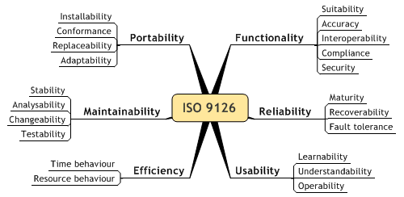

## Controls for external entities

# Team members

4 team members

* 2 Programmer
* 2 Artist

# Quality Pocily

本公司质量方针的特性包括﹕

新会厂在下列情况下需进行质量策划﹕

1. 初建质量管理体系﹔
2. 改进现有质量管理体系﹔
3. 公司内部环境发生变化﹐如﹕质量方针修订等﹔
4. 公司外部条件发生变化﹐如﹕法律法规修订后提出了新要求﹐市场情况发生重大变化。

5.4.2.2 质量策划的内容应包括﹕

1. 依据质量方针﹐制定相应的质量目标﹔
2. 识别为实现质量目标所需的质量管理体系的过程﹔
3. 确定为实现质量目标所需要的资源﹔
4. 定期评审﹐确保持续改进。
5. 质量策划的输出所形成的文件(如质量手册﹑质量程序或质量计划等 )应当始终保持与公司的质量目标相适应﹐当公司对现存的质量管理体系进行更改或公司其它状况发生变化时﹐对这些文件要做相应的更改﹐以确保整个体系的完整性。
6. 5.4.2.4 编制质量计划是质量策划的一部份﹐质量计划是质量策划的结果之一。
7. 相关文件﹕质量目标实施情况检查表﹑质量计划

# adopted Standards

iso9000

Gap Analysis Checklist

Quality Policy

Quality Manual

 Procedures

Work Instructions

Records

8 principles

<http://www.abtrex.com/wp-content/uploads/2009/12/Abtrex-QMSHierarchy.gif>

<http://usercontent2.hubimg.com/3796577_f1024.jpg>

Coding standard

UI standard

ISO 9126

# Orgnination

### Project Lead/ Manager:

* Establishing the quality policy
* Ensuring quality objectives
* Establish, implement and maintain a quality management system
* Responsible to tell all staff the importance of consistent output quality concepts
* Awareness and compliance with laws and regulations of sale
* Setting quality objectives
* Conducting management reviews
* Ensuring access to the resources needed
* Approval of all employees salary, hiring and/or dismissal
* Approval of the company's quality manual
* Approved budget expenditures within operating limits
* Approved main suppliers and outsourcing providers
* Responsible for developing and maintaining a quality manual
* Responsible for establishing and maintaining quality management system implementation
* Performance reporting quality management system and the need for improvement
* Internal audits and management reviews

### Programmer Lead

* Maintain and continually improve the daily operations of the Department of Research and Development and Quality Assurance Department
* Address issues related to the quality

### Artist Lead

* Maintain and continually improve the daily operations of the Department of Research and Development and Quality Assurance Department
* Address issues related to quality

### Designer Lead

* Maintain and continually improve the daily operations of the Department of Research and Development and Quality Assurance Department
* Address issues related to quality
* Product Development

### Test Lead

* Maintain and continually improve the daily operations of the Department of Research and Development and Quality Assurance Department
* Address issues related to quality

### Customer Services

* Answering and tracking customer complaints
* Accept and address complaints from customers, in cooperation with relevant departments, to identify the causes and determine solutions

### ???lead

* To maintain and continue to improve the daily work of the Department of Logistics
* Supervise the performance of the logistics general manager of various departments to achieve management objectives
* Responsible for communication and logistics business-related government departments
* Maintain good communication with the relevant supplier’s
* Logistics cost control。
* Activities to ensure and monitor the entire production planning department operates within the norms according to ISO9001
* Training, management and monitoring of production planner

### HR

* Planning and implementation of year-end employee performance review. Ensure proper implementation of the staff salaries and benefits. Provide the right balance of the number of paid holidays, so that employees can more easily arrange holiday time.
* Monitoring the probationary staff until the ceasing of the trial period, as well as administer performance review from probationary period.
* Provide monthly or quarterly orientation for new employees. Assist in the training of employees according to the description of each sector to provide jobs and develop training programs. As well as continue to watch the progress and development of new training methods.
* Resolve complaints of employees and provide dispute resolution for conflicts between employees.
* Contact Quality Management System matters related to external parties.
* As the company's policy or program files experience any change, notify staff.
* Utilize security guards, and refuse former employees or unauthorized visitors to enter the company.
* Authorizing payment of compensation and retention of medical expenses for all employees’ record.

### Responsibilities

|  |  |  |  |  |  |  |  |  |
| --- | --- | --- | --- | --- | --- | --- | --- | --- |
|  | Project Lead | Programmer Lead | Artist Lead | Designer Lead | Test Lead | HR Lead | ??? Lead | ??? Lead |
| Kitman Yiu |  |  |  |  |  |  |  |  |
| Michael Brown |  |  |  |  |  |  |  |  |
| Trent |  |  |  |  |  |  |  |  |
| Locken |  |  |  |  |  |  |  |  |

### Documentation

|  |  |  |  |  |  |
| --- | --- | --- | --- | --- | --- |
|  | GDD | TDD | Project Management Plan | Test Plan | Post Morden |
| Project Lead |  |  |  |  |  |
| Programmer Lead |  |  |  |  |  |
| Artist Lead |  |  |  |  |  |
| Designer Lead |  |  |  |  |  |
| Test Lead |  |  |  |  |  |
| HR Lead |  |  |  |  |  |
| ??? Lead |  |  |  |  |  |
| ??? Lead |  |  |  |  |  |

# Records and reports

## Quality Planning

The following documentation is created to ensure the purpose criteria within the LWQMS are sufficiently addressed:

* Procedures
* Work Instructions
  + Game Design Document
  + Technical Design Document
  + Project Manager Documents
  + Test Plan Documents
  + Post Modern

A description is provided below to explain its purpose as well as the areas which will be improved:

* **Procedures**

An official [document](http://www.businessdictionary.com/definition/document.html) [produced](http://www.businessdictionary.com/definition/produce.html) by a [business](http://www.businessdictionary.com/definition/business.html) that details how its [quality management system](http://www.businessdictionary.com/definition/quality-management-system-QMS.html) [operates](http://www.businessdictionary.com/definition/operate.html)

* **Work instruction**

**QMS Document**

**This is the current QMS document.** This documentation, determining which standards or documentation will be applied, not only ensures the quality of the game, but also ensures that the game environment can be setup to reach the quality of the game. However, the procedure to reach these benchmarks of quality will not be in this documentation.

* **Technical Design Documentation(TDD)**

The technical Design Document will be mainly created and used by the programmer.

The goal of this documentation is instruct the programmer on how to create this game.

The document is too improve the following points from within the Purpose of the LWQMS:

* + Quality of Story
  + Quality of Game Mechanics
  + Quality of Audio
  + Quality of Visual Effect
  + Reliability
  + Usability
  + Flexibility
* **Game Design Documentation(GDD)**

The Game Design Document will be mainly create by Designers and Artist.

The goal of this documentation is too present the game idea and what element are in the game.

* The document is too improve the following points from within the Purpose of the LWQMS:
  + Quality if Game Mechanics
  + Reliability
  + Efficiency
  + Integrity
  + Usability
  + Maintainability
  + Testability
  + Flexibility
  + Reusability
  + Interoperability
  + Security
  + Safety
* **Project Management Plan**

This document will be created by the team leader or project manager.

The goal of this documentation is too create a plan which provides steps to manage your project.

The document is to improve the following points from within the Purpose of the LWQMS:

* **Marketing plan**

This document will be managed by the marketing team or the team leader in small organizations.

The goal of this document is to create a plan which can increase the sales of the game.

The document is to improve the following points from within the Purpose of the LWQMS:

* **Test Plan Document**

This document will created by the test team or team leader.

The purpose of this document will be to determine what items need to be tested and how these items can be tested.

The document is to improve the following points from within the Purpose of the LWQMS:

* **Post Modern:**

This documentation will be written by the project lead or team leader.

The goal of this document is to do revision, determine mistakes and provide solutions, as well as positive aspects of the game which should be kept for the next project.

The document is to improve the following points from within the Purpose of the LWQMS:

* **Feedback and Quality Problems Solutions: PDCA report**

This documentation template can be written by any team members who are working on this project.

This documentation template reports any quality issue.

The document is to improve the following points from within the Purpose of the LWQMS:

A standard template will be provided for the documentations

## Quality Control

### Records collection, maintenance, and archiving

As least three records will be backed up and the final documentation will be kept by the project leader, as this will improve the following points:

To allow the documentation to reach the following condition:

The naming of the filename will be provided below: xxxDoc_V (version), example GDDDoc_V1, as this will improve the following point.

## Quality Ensure

To ensure the documentation reaches the standard set out in the Quality Planning.

There will be a checklist for the project manager to check.

All team members must be able to understand the documentation.

To ensure there is not too much or too little documentation.

## Quality Improvement

The following lifecycle will be applied to the documentation:

To improve the documentation, the following process would need to be done:

# ToolS, techniques, methods

## Quality Planning

The using the following software it will improve the following points

* Reliability
* Efficiency
* Integrity
* Usability
* Maintainability
* Testability
* Flexibility
* Portability
* Reusability
* Interoperability
* Security
* Safety
* Design
* Developer
* Purchasing Control
* Production Control
* Customer feedback

The following tools can be considered while developing the project:

|  |  |  |  |
| --- | --- | --- | --- |
| Name | Type of Tool | Description | Link |
| Teamwork Project | Team Management Tool | Price : 10/per month AUD  Pros :   * Easy to use * Stable * Cheap   Cons :   * Still waiting them to develop charts to able to visualize the result more easily | <https://www.teamwork.com/projects> |
| ProWorkFlow | Team Management Tool | Price : 10/per month AUD (one user only)  Pros :   * Easy to use * Stable * Inexpensive   Cons :   * The Gantt does not show dependency |  |
| Teamwork Desk | cloud-based customer support software | Price: Free 150 Tickets every month. After $0.05 per-ticket  Pros :   * Easy to use * Stable * Inexpensive   Cons :   * To be determined | <https://www.teamwork.com/desk> |
| Intelex | QMS Tool | Price: Unknown  Pros :   * Easy to use. * Stable. * Have Trial version to test. * Follows ISO9001 Standard   Cons :   * To be determined | <http://www.intelex.com/landing/Intelex_Quality_Management_System-300campaign.aspx?source=h%2b1cla%2byaKH2gBG7oq333hx90y0Zs0roSd50rCzALwaaTS4x9gyVILMtWyOgGyzOEA5bayvsz%2frML8PB%2fHlccA%3d%3d&gclid=CjwKEAjw-ZqrBRDt_KjhjcbzhhISJAAlRGvlBXvW0RSxpgIoS146i52xwcYqC0g2PtHccuW-me0-JBoCt2jw_wcB> |
| Quality Assurance Evaluation | QMS Tools | Price: $299 for One (Annual Fee)  $499 for two (Annual Fee)  $999 for two (Annual Fee)  Pros :   * Easy to use. * Stable. * Have Trial version to test.   Cons :   * To be determined | <http://www.maus.com.au/product/maus-quality-hub/?gclid=CjwKEAjw-ZqrBRDt_KjhjcbzhhISJAAlRGvl40lGcaXZ6MyLFRJZyvxOIBIPHPcBuziL-xqGHi_yBBoC1P7w_wcB> |
| Skype | Communication software | Free  providing [video chat](http://en.wikipedia.org/wiki/Videotelephony) and voice calls from computers, tablets, and mobile devices via the Internet to other devices or telephones/smartphones  MUST BE installed and USED on EVERY COMPUTER | <http://www.skype.com/en/> |
| Team viewer | Communication software | Free  is a software proprietary [computer software](http://en.wikipedia.org/wiki/Computer_software) package for [remote control](http://en.wikipedia.org/wiki/Remote_control_(computing)), [desktop sharing](http://en.wikipedia.org/wiki/Desktop_sharing), online meetings, [web conferencing](http://en.wikipedia.org/wiki/Web_conferencing) and [file transfer](http://en.wikipedia.org/wiki/File_transfer) between computers.  MUST BE installed and USED on EVERY COMPUTER | <https://www.teamviewer.com> |
| XMind | Mind map tool | Free  A Software which supports [mind maps](http://en.wikipedia.org/wiki/Mind_maps), [fishbone diagrams](http://en.wikipedia.org/wiki/Fishbone_diagram), [tree diagrams](http://en.wikipedia.org/wiki/Network_topology#Tree), [organization charts](http://en.wikipedia.org/wiki/Organization_chart), spreadsheets, etc. Normally, it is used for knowledge management, meeting minutes, task management, and [GTD](http://en.wikipedia.org/wiki/Getting_Things_Done). On the other hand, XMind can read [FreeMind](http://en.wikipedia.org/wiki/FreeMind" \o "FreeMind) and [MindManager](http://en.wikipedia.org/wiki/MindManager" \o "MindManager) files, and save to [Evernote](http://en.wikipedia.org/wiki/Evernote)  MUST BE INSTALLed and used by EVERY PROGRAMMER IN THE TEAM | <http://www.xmind.net/download/win/> |
| Google Chrome |  | freeware web browser developed by **Google**  MUST BE INSTALLed and used by EVERY PROGRAMMER IN THE TEAM | <http://www.google.com/chrome/> |

b) 顾客投诉的处理﹔

## Quality Control

N/A

## Quality Ensure

The make sure the software is reliable to use and easy to use the following metrics can be applied to test:

Number of customer that is using the software

The satfiaction of other customer

A 1- 10 easy and hard thing, and let teammember to test out how easy to use

Too ensure not too much software and too less software to be use

To ensure that efficient amount of software is being used so as to not slow down the process of designing and programming the game.

(organizing my thinking)

## Quality Improvement

Project manager will be look up new software that exists on the web, if there are new software and it is easy to use. Use it in next project.

Each time a new software has been included the following we need to be tested

# Training required

## Quality Planning

The following training we be applied to the employee

### Software Training

|  |  |  |  |  |  |  |  |  |
| --- | --- | --- | --- | --- | --- | --- | --- | --- |
|  | Teamwork Project | Teamwork Desk | Intelex | Quality Assurance Evaluation | Skype | Team viewer | XMind | Google Chrome |
| Project Lead |  |  |  |  |  |  |  |  |
| Programmer Lead |  |  |  |  |  |  |  |  |
| Artist Lead |  |  |  |  |  |  |  |  |
| Designer Lead |  |  |  |  |  |  |  |  |
| Test Lead |  |  |  |  |  |  |  |  |
| HR Lead |  |  |  |  |  |  |  |  |
|  |  |  |  |  |  |  |  |  |
|  |  |  |  |  |  |  |  |  |
| Artists |  |  |  |  |  |  |  |  |
| Programmers |  |  |  |  |  |  |  |  |
| Designers |  |  |  |  |  |  |  |  |
| Others |  |  |  |  |  |  |  |  |

### Customer Server Training

The will apply to the HR department

|  |  |  |  |
| --- | --- | --- | --- |
| **Name** | **Price** | **Company Background** | **Website:** |
| Select Training | Unknown | Select Training proudly offers flexible tailored Sales and Customer Service Training courses to Australian and International Businesses. Based in Sydney we cater to all Business management courses and the training needs of your employees. We develop our Professional training courses by getting to know you, your Business, the needs of your customers and team. | <http://www.selecttraining.com.au/customer_service_training?gclid=CjwKEAjw-ZqrBRDt_KjhjcbzhhISJAAlRGvlNffg4xYX8g2TSILRZ8kloVqgui6oAXmuXJkuHBsafxoCI5vw_wcB> |
| Open Training | Unknown | [Similar to TAFE](https://www.opentraining.edu.au/similar-to-TAFE), we offer nationally accredited online diplomas and certificates that are recognized by Australian employers, registered training organizations and Australian universities. | <https://www.opentraining.edu.au/courses/customer-sales-service?mkwid=sYuykov7j&pdv=c&pcrid=62823419786&pkw=customer%20service%20training&pmt=e&gclid=CjwKEAjw-ZqrBRDt_KjhjcbzhhISJAAlRGvllqBGpRcFg8qk2Zot4HiDfmkN-S7DAiYdWCRU51thuxoCH8Pw_wcB> |

## Quality Control

N/A

## Quality Ensure

After training, an employee evaluation form will be utilized to assess the effectiveness of the training provided; employee evaluation forms will be provided in the Documentation Template section.

Human Resources Lead will be responsible for keeping records related to educational or training, skills and experience.

Too ensure not too much and too less traning has been done we can

## Quality Improvement

Internet Source

Courses in Sydney which can be joined

# Risk management

## Quality Planning

The risk will be put in project management document

The follow is the flow of

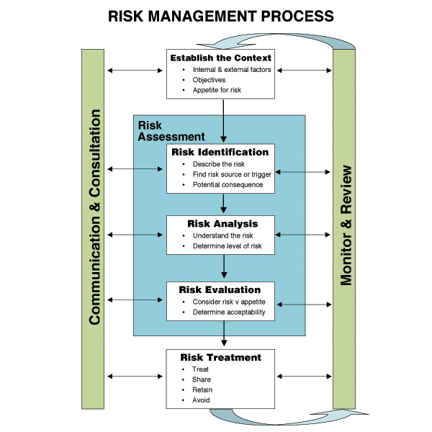

More details in steps

|  |  |
| --- | --- |
| **Steps 10 Step Quality Risk Management Quality Risk Management**  1. Collect and organize information  2. Identify the risks  3. Select Tools  4. Determine the level of risks  5. Determine the size of the various components of risk  6. Determine the Model  7. Determine whether or not to take action limits the use of the tool  8. The application of tools  9. Determine risk reduction measures  10. Document approval | Analysis  Output and verification  Evaluate  Identify  Lower |

### Step 1 - gather and organize information

* Collect relevant information and documentation
  + PQSs, regulations, data, etc.
* Determine any background and preliminary information
* Agreed to assume
* Tool used for organizing existing information
  + Brainstorming
  + Production flow charts
  + Technology process diagrams

### Step 2 - determine risk

* Risk management is the effective output quality; you must explicitly define the initial risks.
* A clear definition of risk focusing on:
* Focus target
* Clear risk areas
* Ensuring effective use of resources
* Providing background

## Quality Control

### Step 3 - Select Tools

|  |  |  |  |  |
| --- | --- | --- | --- | --- |
| Tool | Includes | Scale | Scale projects | Critical point |
| RRF- risk Sorting and filtering | S×P | Large, medium and small | Not defined | Using a standard model. The emergence of large-scale risks must take action. (The size of the risk in considering whether to take action) model is ready for action and defined conditions. According to the conditions defined risk factor for action |
| PHA- preliminary risk analysis | S×P | Large, medium, small or other | Each scale projects are clearly defined for each scale projects are clearly defined | Using a standard model. The emergence of large-scale risks must take action. (The size of the risk in considering whether to take action) model is ready for action and defined conditions. According to the conditions defined risk factor for action |
| FMEA- failure mode effect analysis | S×P×D | Number | Each scale projects are clearly defined for each scale projects are clearly defined | Using a standard model. The emergence of large-scale risks must take action. (The size of the risk in considering whether to take action) model is ready for action and defined conditions. According to the conditions defined risk factor for action |

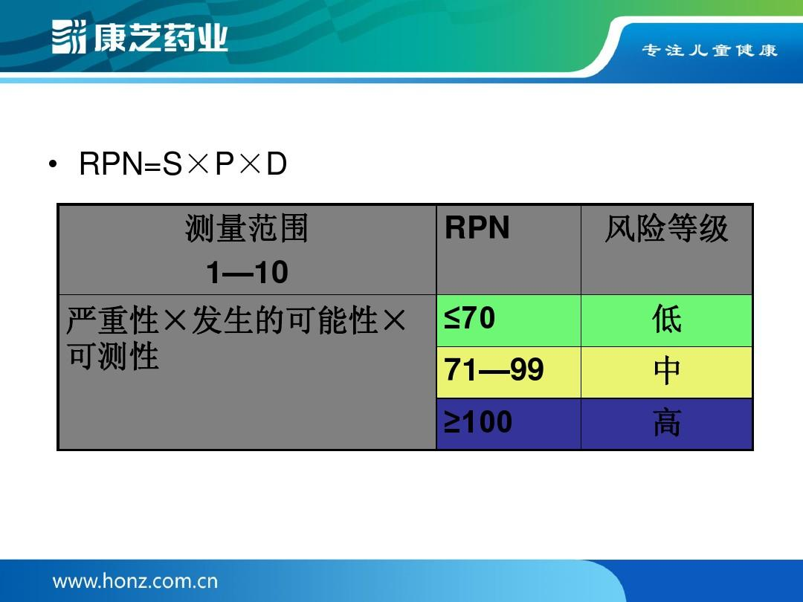

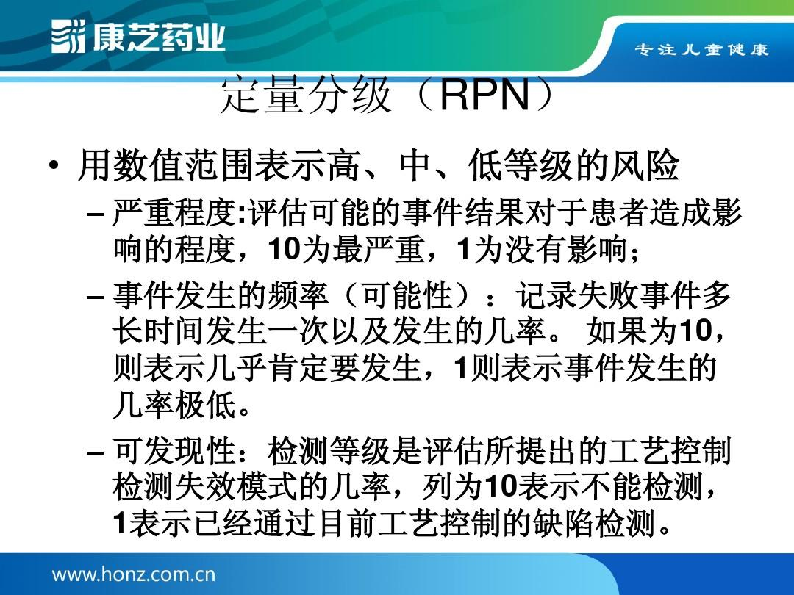

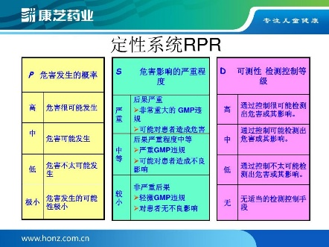

### Step 4 - determine the risk factors

* Severity
  + That affect patient / compliance / company factors that must be considered. Risk factors are likely to contain more than ????
* Probability
  + Probability of patients / compliance / company influential happen much?
* Monitor
  + You can monitor the risk? Remember monitoring will lead to high-risk low

### Step 5 - determine the risk factors

|  |  |  |  |  |
| --- | --- | --- | --- | --- |
| Greater the Problem | Description and Definition |  | Greater the frequency | Description and Definition |
| **Very serious** | Won’t be able to publish the game |  | **Frequency** | Happened more than 10 times |
| **High risk** | The quality can impact the sales of the game |  | **Often** | Happened more than 5 times |
| **Low risk** | The quality is low, but has limited impact to the sales of the game |  | **Occasionally** | Happened more than 3 times |
| **Insignificant** | Feels uncomfortable, but will not have impact to the sales of the game |  | **Scarcely** | Happened more than 2 times |

### Step 6 - defined matrix

Greater the frequency

|  |  |  |  |  |
| --- | --- | --- | --- | --- |
|  | **Negligible** | **slightly** | **higher risk** | **Very serious** |
| **Frequency** | High | Medium | High | High |
| **Often** | Medium | Low | Medium | High |
| **Occasionally** | Low | Low | Low | Medium |
| **Scarcely** |  | Low | Medium | High |

Greater the Problem

### Step 7 to determine whether to take action limits

|  |  |
| --- | --- |
| High | Must reduce risk |
| Medium | Reduce the risk to a reasonable range |
| Low | In consideration of the cost / benefit situation, it will reduce the risk to a reasonable range |
| Insignificant | Mostly acceptable levels |

## Quality Ensure

N/A

## Quality Improvement

To keep able to minizle the risk

### Step 8 - use tool

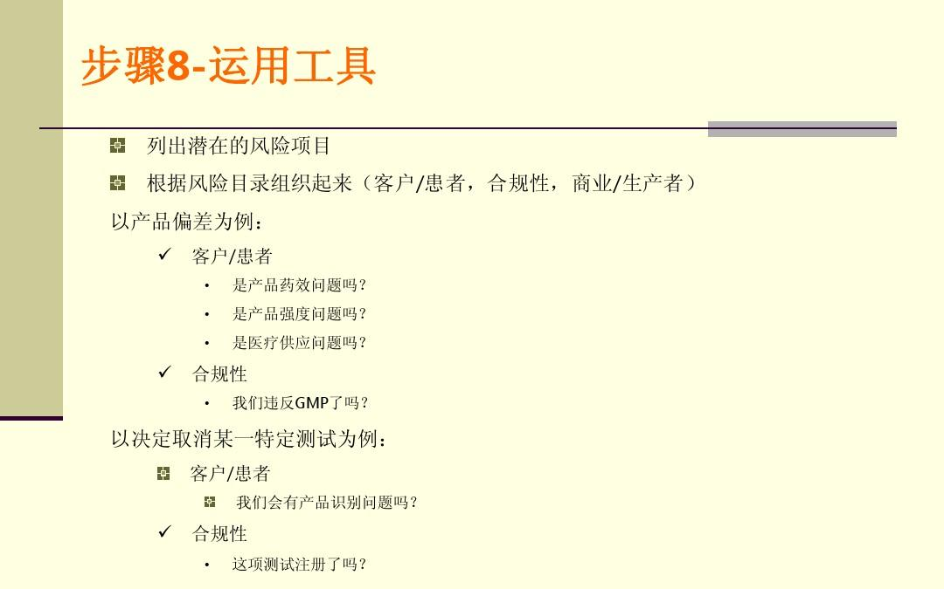

* Potential risks listed items:
* Directory organized according to the risk (client / patient, compliance, business / producer) product deviations
  + client
    - Efficacy problem?
    - Product strength is the problem?
    - Medical supply problem?
  + Compliance
    - violate our GMP yet?
* To decide to cancel a particular test as an example:
* client
  + Will we have the product identification problems?

### Step 9 definition of risk reduction measures

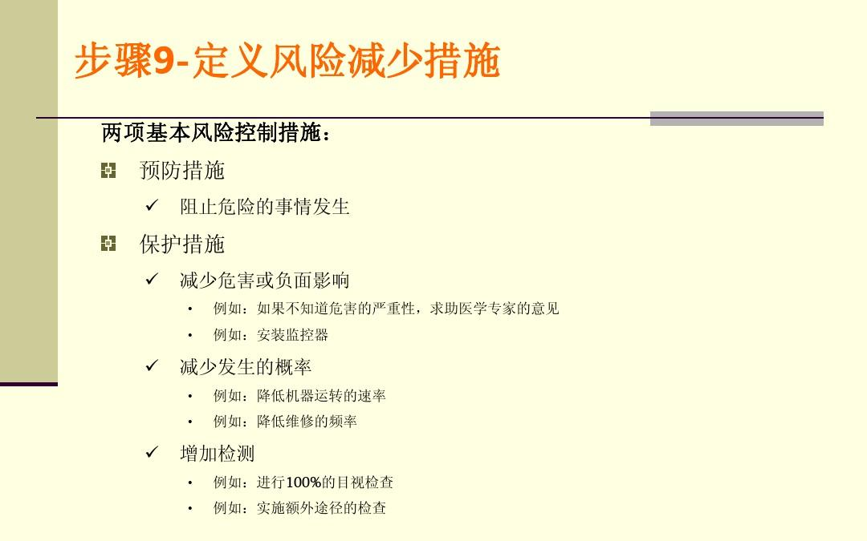

Two basic risk control measures:

* Precaution
  + Prevent dangerous things from occurring
* Safeguard
  + Reduce harm or negative impact
    - For example: If you do not know the severity of the harm, help medical experts opinions
    - For example: installation of monitoring devices
  + Reduce the probability of occurrence
    - For example: to reduce the rate of operation of the machine, for example: reduce the frequency of maintenance
  + Increase the detection
    - For example: 100% visual inspection such as: implementation of the inspection additional pathway

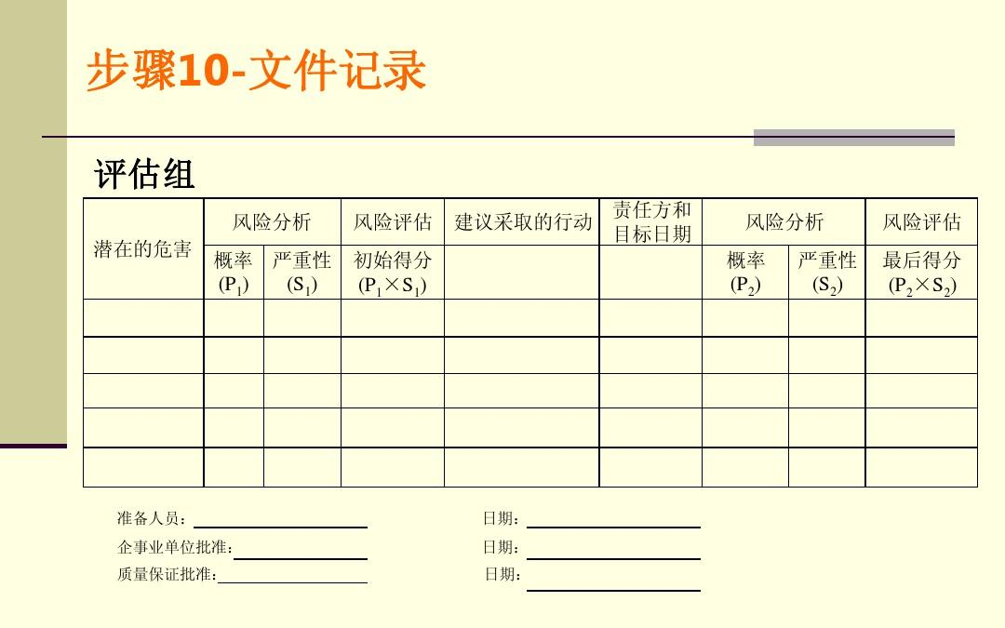

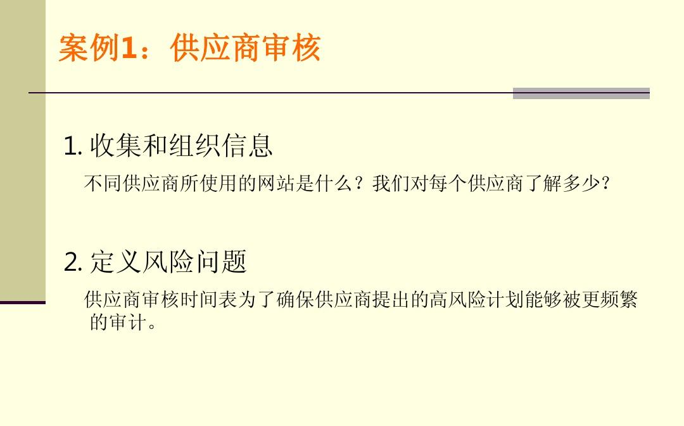

# QA metrics

## Quality Planning

b) 顾客投诉的处理﹔

to able to test the story quality in GDD

to be able to test the audio quality in GDD

to be able to test the GUI quality in GDD

To be too test the reviews and audits increases our quality

To be able too test does the system of quality problrems and corrective action

to able to test does the software increase our deveoplement time

To able to test should we use the software

## Quality Control

Control not too much or too little metrics

## Quality Ensure

To ensure the metrics are all test we can …..

## Quality Improvement

Can be added base on the following condition

# Reviews and AUDITS (审核与审查)

## Quality Planning

The following metrics is able to reviews and audits

b) 顾客投诉的处理﹔

The goal of Reviews and Audits

Auditing is an effective management tool for inspection activities and processes, the results of an examination for managers to take steps to provide information. The main purpose of the audit is to determine the procedures to meet the audit criteria, such as: determining the auditee's management system conformity to requirements; evaluation of compliance with regulations. Confirm the effectiveness of the implementation of the management system to meet specified objectives. In short, to carry out an internal audit is to ascertain the effect of the implementation of the quality management system has reached the target required by the inspection agencies of the established quality management system, to detect problems in order to demonstrate and by taking preventive measures to further improve compliance and effectiveness of the quality management system

审核是对活动和过程进行检查的有效管理工具，审核的结果为管理者采取措施提供了信息。审核的主要目的是确定满足审核准则的程序，如：确定被审核方的管理体系对规定要求的符合性；评价对法规的符合性。确认所实施的管理体系满足规定目标的有效性。总之，开展内部审核是为了查明质量管理体系的实施效果是否达到了按质检机构的目标所建立的质量管理体系的要求，及时发现存在的问题，以便通过采取论证和预防措施，来进一步提高质量管理体系的符合性和有效性

**．The principle of audit**

**To ensure the effectiveness and efficiency audits, uy should adhere to three important principles of objectivity, independence and systematic approach to auditing.**

* **Audit objectivity**
* **Audit independence**
* **Systems approach audit**

**Type quality system audit**

**(1) Internal Audit**

**(2) External audits**

## Quality Ensure

## Quality Improvement

The reiviews will be add and decreae base on …

# Quality problem reporting and corrective action

## Quality Planning

Flow chart

1. Download Template
2. Filled in template
3. Summit template (see above )

If something goes wrong in the interal audit what is going ti happen

## Quality Control

Have a checklist to check is all the things be include

## Quality Ensure

It the probrem have been fix or it does not appear more than 3 times

## Quality Improvement

The template is based on these condition

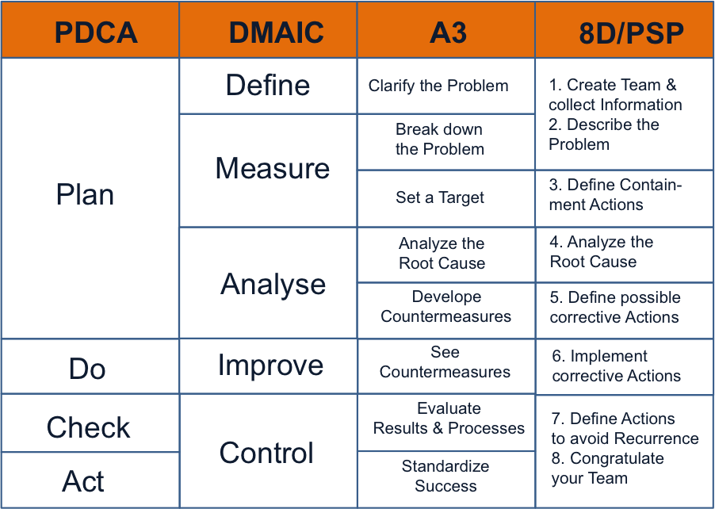

顾客满意度调查﹔

**6.3 设施**

**7.2.3 顾客沟通 what information need from customer to improve the**

新会厂为使供求双方的沟通能有效地进行﹐特别由生产计划部﹑R&D﹑QA部负责与顾客沟通﹐其内容包括：

The following template is to ensure that the game design document reaches the things above:

Some things is really important that you must follow

The empoyees have to sumbit that as avendince

To able to report problem the ?? team we create a website , in every computer they will need to make a link on destop , so as following image:

The user have two types of doc one is about the SDLC and the is about the system, the format is showed below

ID

Type of QA problem

Description (need to be SMART)

Priority

Corrective Actions

The steps if feedback from customer

Reply email as following format

# Reference

What is an ISO 9001 Quality Management System? How does a ISO 9001 QMS Work?. 2015. What is an ISO 9001 Quality Management System? How does a ISO 9001 QMS Work?. [ONLINE] Available at:<http://the9000store.com/what-is-iso-9001-quality-management-system.aspx>. [Accessed 29 May 2015].

What is lightweight? - Definition from WhatIs.com. 2015. What is lightweight? - Definition from WhatIs.com. [ONLINE] Available at: <http://whatis.techtarget.com/definition/lightweight>. [Accessed 29 May 2015].

What is Quality? definition and meaning. 2015. What is Quality? definition and meaning. [ONLINE] Available at: <http://www.businessdictionary.com/definition/quality.html>. [Accessed 29 May 2015].

Management system standards - ISO. 2015. Management system standards - ISO. [ONLINE] Available at: <http://www.iso.org/iso/home/standards/management-standards.htm>. [Accessed 29 May 2015].

<http://www.wendangwang.com/doc/4442ef182dcbcb07d897e531/13>

<http://www.wendangwang.com/doc/9e68b5a4e6d2859d13d916a7/12>

<http://www.chinacmmi.com/BusinessField.aspx>

<http://tech.eol.com.cn/?cat=35>

<http://www.chinadmd.com/search.do?nkey=%E5%91%98%E5%B7%A5%E8%AF%84%E4%BB%B7%E8%A1%A8>

<http://iso9001-2008awareness.blogspot.com.au/2009/08/internal-audit-of-quality-management.html>

design and demonstrate a lightweight quality management process that may apply in a games environment

design and demonstrate a lightweight quality management process for a games environment and game

design and demonstrate a lightweight quality management process for a game in a games environment